Quick start guide for Robotic Sailboat navigation hardware platform

All the navigation and sensor data will be handled by Arduino

Raspberry Pi ONLY do heavy computational jobs to save power

PART 1. Core system using Arduino

1. Download Arduino IDE
2. Go to Arduino.cc and click download tag

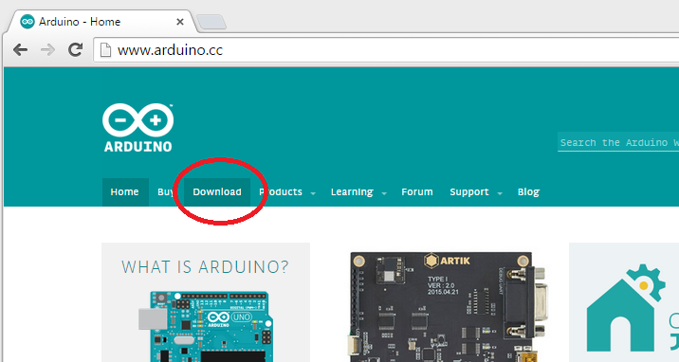

1. Choose your desired version

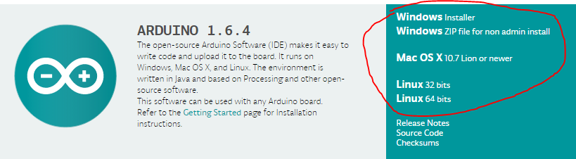

1. Install the IDE
2. Plug the USB cable in your Arduino as well as your computer (like connect your cell phone to the computer)
3. Open Arduino IDE by double click the icon



1. Select the board you are using

(We will use Arduino Mega 2560 for our project, but I only have Arduino Micro for this tutorial)

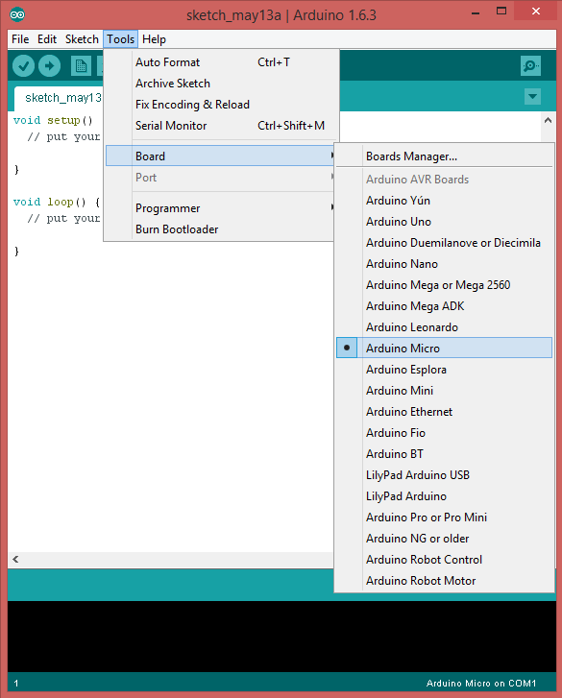

1. Select COM port of the Arduino

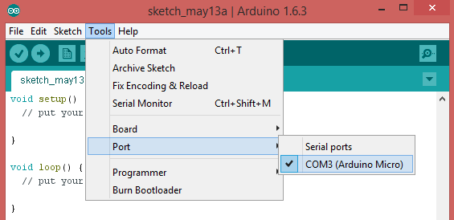

1. Now try to compile and burn a program into Arduino

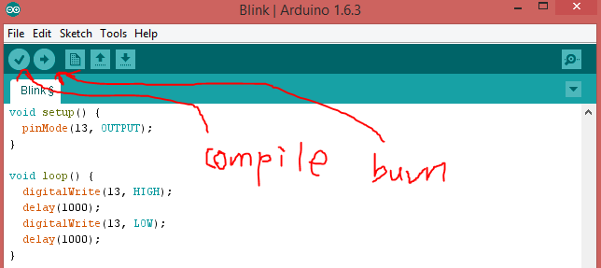

Click the “Compile(Verify)” button to compile the program

Click the “Burn(Upload)” button to compile and then burn the program into Arduino

After several seconds, you can see the LED on the Arduino board blinks.